10-Day Detox Diet
Your Six Prep Steps
(Chapter 6)

Step 1 – Detox your Kitchen | Step 2 – Gather supplies | Step 3 – Taper off caffeine, alcohol, and sugar
Clean out your cupboards and refrigerator to eliminate foods you can’t eat during the detox  - Anything that is not a real food (in a box, package, or can)  - Only canned whole foods with a couple ingredients, such as sardines or artichokes are allowed  - Hydrogenated or refined vegetable oils (corn, soybean)  - Foods with sugar in any form (honey, molasses, agave, maple syrup, cane juice, sugar)  - Artificial sweeteners, preservatives, additives, colors, dyes  - All gluten products (bread, pasta, bagels, etc)  - All grains (even gluten-free)  - All dairy (milk, yogurt, cheese)  - All beans | Review the meal plan starting on p261 to become familiar with what you can eat and the recipes you can choose from  Grocery shop – p257-258 provides the list of staples you will need to shop for  Items needed for optional components beyond the food portion of this detox:  - p101 – bath supplies  - p101 – detox journal  - p103 – supplements  - p104 – optional testing tools  - p105 – exercise apparel  - p105 – water filter and bottle | Dr Hyman recommends a two-day prep phase to taper off/eliminate caffeine, alcohol, and sugar  Two days prior, drink half your usual dose of caffeine; One day prior drink half what you drank the day before and then on the first day of the 10 days, you will drink no caffeine  How to deal with the decrease in caffeine (p106):  - Take a nap if you are tired  - Gentle exercise  - Drink a lot of water  - Extra Vitamin C (1,000 mg twice/day)  - Ibuprofen if necessary (400 mg)  Stop alcohol cold turkey, as well as sugar and artificially sweetened drinks
Step 4 – Align your mind and intentions | Step 5 – Measure yourself | Step 6 – Join the Blood Sugar Solution online community
A big portion of the battle when it comes to doing a cleanse or detox is becoming mentally prepared for what you are about to embark on  Use your journal to respond to the questions on p107 | The day before you start the detox, measure your weight, height, waist, hips, thigh circumference, and blood pressure (p108-109)  Complete the toxicity questionnaire (p5-7) | Go to the online community and use the support provided  www.10daydetox.com/resources  Reach out to me via phone or email  602-421-4407  michele@inspearationalhealth.com

10-Day Detox Diet
What Your Daily Meals Look Like
(Chapters 20 & 21)

Breakfast | Lunch – 3 options – Mix & Match | Dinner – 3 options – Mix & Match | Snacks
Detox Shakes (p267-270)  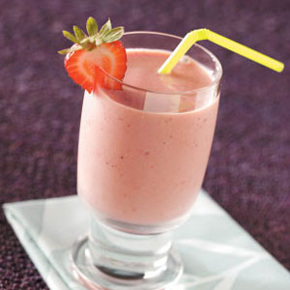  - Whole Food Protein Shake (267)  - Kiwi & Chia Seed Smoothie (268)  - Ginger & Cucumber Smoothie (269)  - Spiced Almond Smoothie (269)  - Almond & Strawberry Smoothie (270) | - Super Salad Bar w/Protein (p271-273)  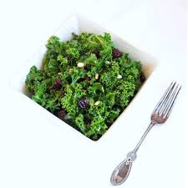  - Soup w/Protein (p273-276)  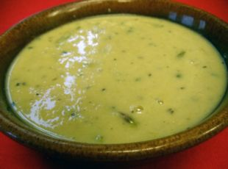  - Adventure plan (p288-300)  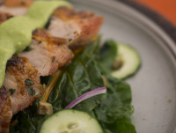 | - Create your own as described in “Cooking the Basics” (p259-261)  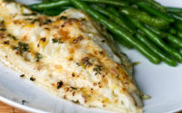  - Protein  - Vegetables  - Unlimited non-starchy vegetables (p255)  - Core plan (p277-287)  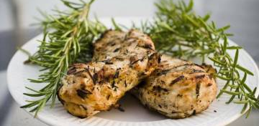  - Adventure plan (p300-317)  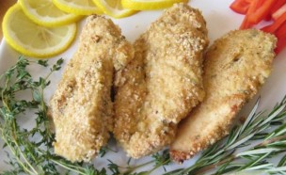 | Mid-morning  10 to 12 nuts  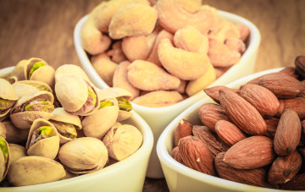  - Almonds  - Walnuts  - Pecans  - Macadamia nuts  Mid-afternoon  Dip or spread (p317-320) w/fresh vegetables  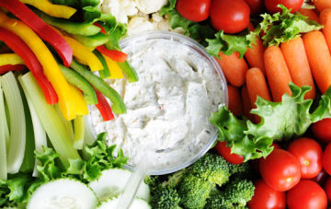  - Homemade olive tapenade (317)  - Tahini dipping sauce (318)  - Spinach & walnut pesto (318)  - Sun-dried tomato dip (319)  - Miso dipping sauce (319)

Smoothie Shopping List (1 of each; 5 days)
frozen blueberries | 0.5 | cup
frozen cranberries | 0.5 | cup
lemon | 1
raw almond butter | 3 | T
pumpkin seeds | 1 | T
chia seeds | 10 | T
hemp seeds | 5 | T
raw walnuts | 5
raw Brazil nuts | 2
avocado | 1
coconut butter | 1 | T
almond milk | 0.5 | cup
kiwi | 1
lime | 1
mint leaves | .25 cup + 8-10 leaves
spinach | 1 | cup
raw almonds | 0.5 | cup
kale leaves | 3 | leaves
ginger root | 1.5 | inch
cucumber | 1
strawberries | 0.5 | cup
cinnamon | 0.25 | t
flaxseeds | 1 | T

